

**Task 1: Preparing Urban Data Layers (Catchment Analyser)**

**Description**

This exercise introduces the Catchment Analyser tool to produce a single station or multiple stations metric catchment analysis. This exercise requires the Public Transport stations dataset and the processed Axial Map Segment Analysis file.

**Stage 1 – Creating the Catchments**

1. **Prepare the project**
   1. Open the ‘sample’ workspace.
   2. Make the **Public_Transport** layer visible
   3. Make the **Axial_Map_Segment_Analysis** layer visible.
   4. Start the Catchment Analyser (Ca) tool from the Space Syntax Toolkit menu or toolbar
2. **Run the catchment analysis for individual origins and all origins**
   1. The aim of this step is to run the catchment analysis for individual stations and for all stations combined (the minimum distance to any station)
   2. For the **network layer**, select the **Axial_Map_Segment_Analysis** layer
   3. For the **origin layer**, select the **Public_Transport** layer
   4. Leave the custom origin names empty, or select **‘ gid’**
   5. For the **cost bands**, type the following distances: **400,800,1200,1600,2000**
   6. Check the **catchment network** and select ‘…’ to browse the location to save the file. Save the file as ‘**catchment_network_station**’.
   7. Check the **catchment polygon** and select ‘…’ to browse the location to save the file. Save the file as ‘**catchments_polygon_station**’.
   8. Press **Run**.
   9. If you have chosen to save the file as temporary layers then the layers need to be saved otherwise they will be lost once the workspace is closed.

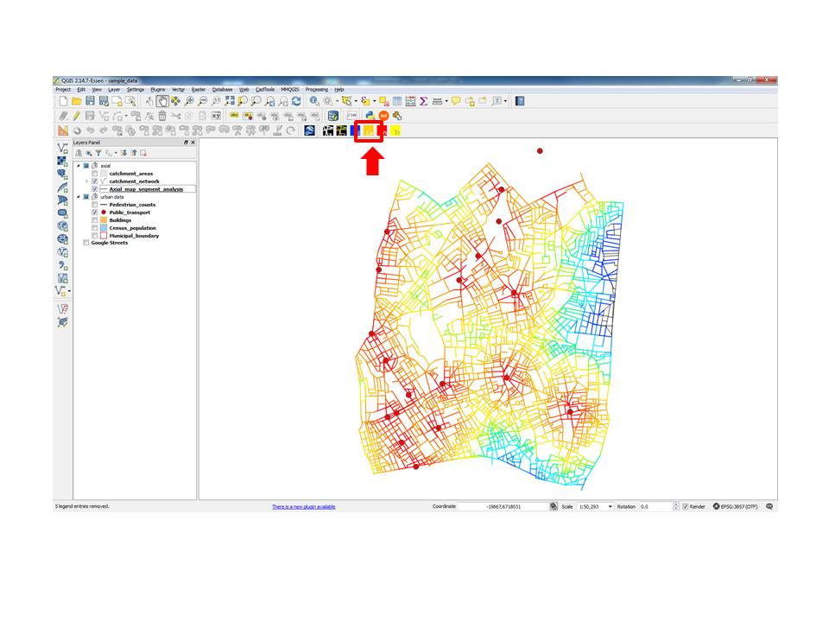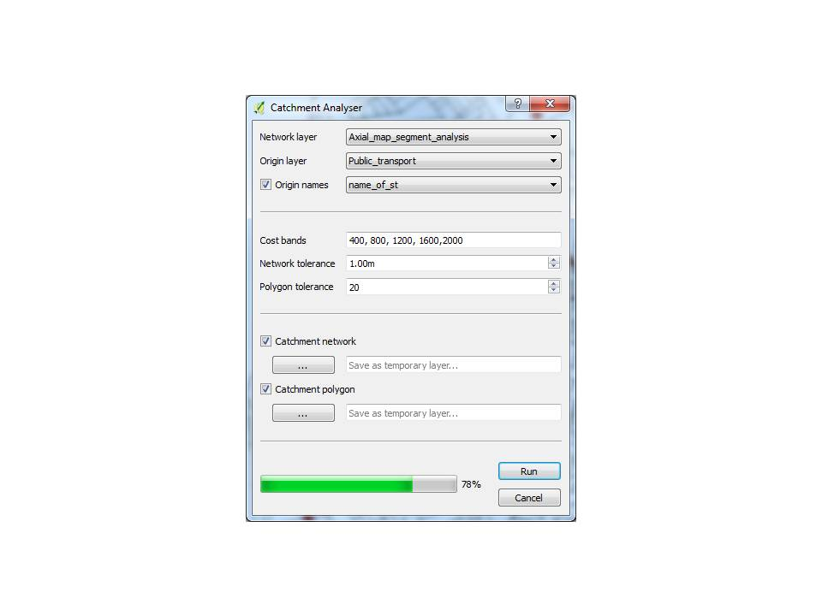

1. **Run the catchment analysis for individual tube lines**
   1. The aim of this step is to run the catchment analysis for the tube station **lines** *rather* than the individual stations
   2. For the network layer, select the layer **Axial_Map_Segment_Analysis**
   3. For the origin layer, select the **Public_Transport** layer
   4. Click on the **custom origin names**
   5. Select "**line**"
   6. This will create the catchment for groups of stations based on the tube line.
   7. For the cost bands, type the following distances: **400,800,1200,1600,2000**
   8. Check the catchment network.
   9. Click on the "..." button to save the catchment network output as a new shapefile.
   10. Check the catchment polygon.
   11. Click on the "..." button to save the catchment polygon output as a new shapefile.
   12. Name these file layers as ‘**catchments_network_line**’ and ‘**catchment_polygon_line**’.
   13. If you leave these blank no files are created, only temporary layers that later need to be saved.
   14. Press Run.
   15. Two layers are created that show these network catchment bands and polygon bands

**Stage 2 – Visualising the Catchments**

1. **Visualise catchment analysis along network**
   1. To visualise the catchment analysis for individual stations, double-click on the "**catchment_network_station**" in the Layers panel
      1. Go to ‘**Style**’
      2. Under **Columns**, select the "station" you would like to visualise (i.e Caledonian Road)
      3. Click OK.
      4. The map shows the catchment for the selected station in your chosen colour gradient.

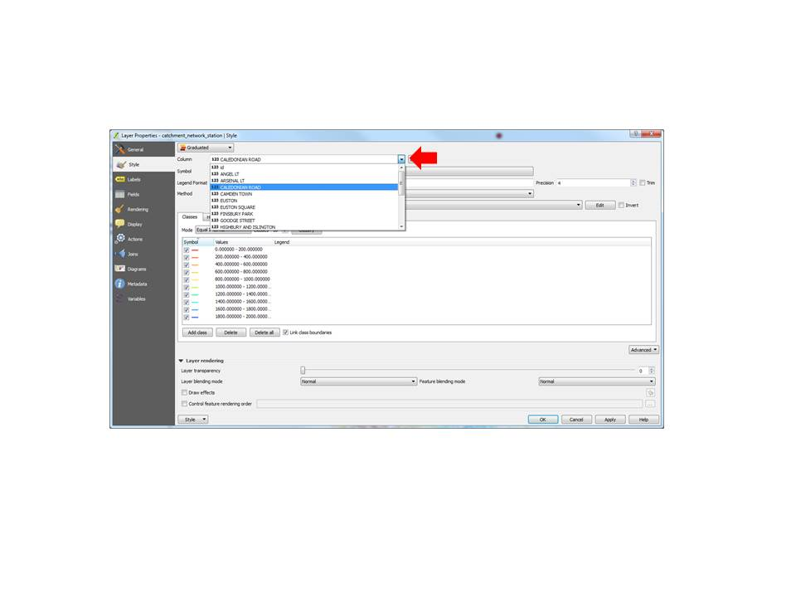

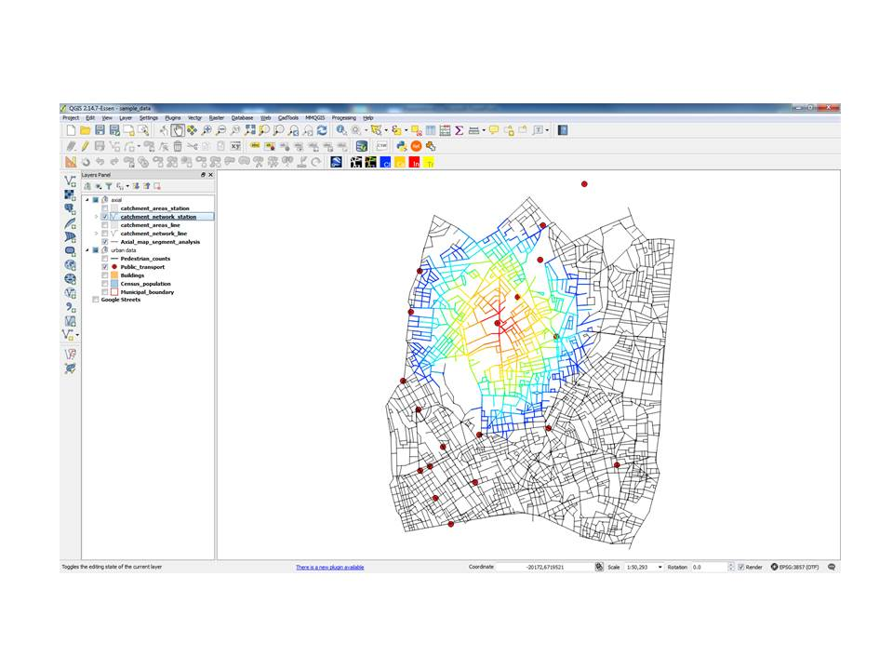

* 1. If you want to visualise the catchment analysis for all the stations, double-click again on the "**catchment_network_station**" under the layers panel
     1. Go to ‘Style’
     2. Under columns, select the "**min_dist**"
     3. Click OK.
     4. The map now shows the catchment from all stations, with the value on each segment being the distance to the nearest station (minimum distance)

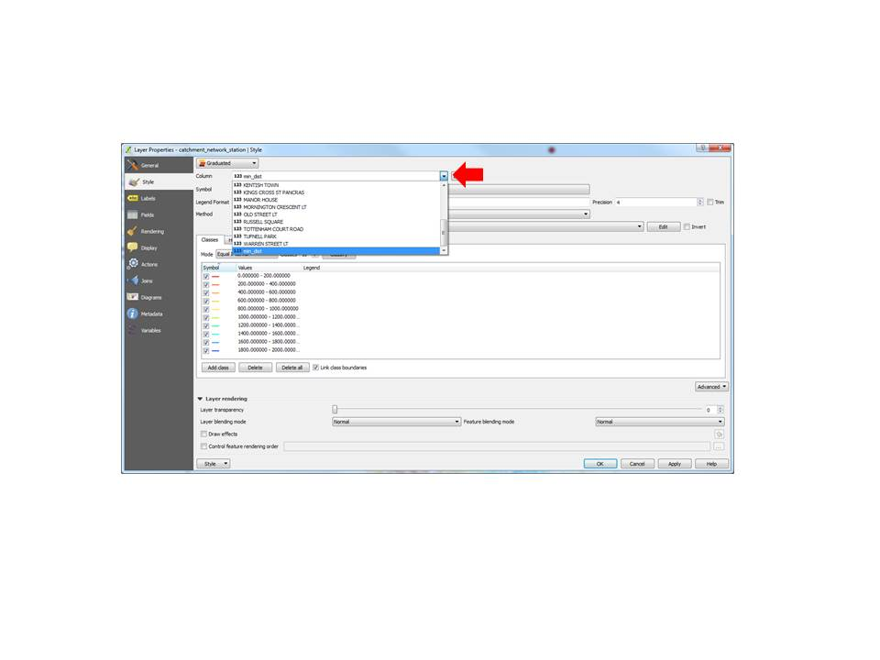

* 1. If you want to visualise the catchment analysis for individual tube lines, double click again on the "**catchment_network_line**" from the line results (Step 3) under the Layers panel
     1. Go to ‘**Style**’
     2. Under columns, select the tube "line" you want to visualise (i.e Piccadilly)
     3. Click OK.
     4. **The map shows the catchment analysis from the stations on the specific tube line**

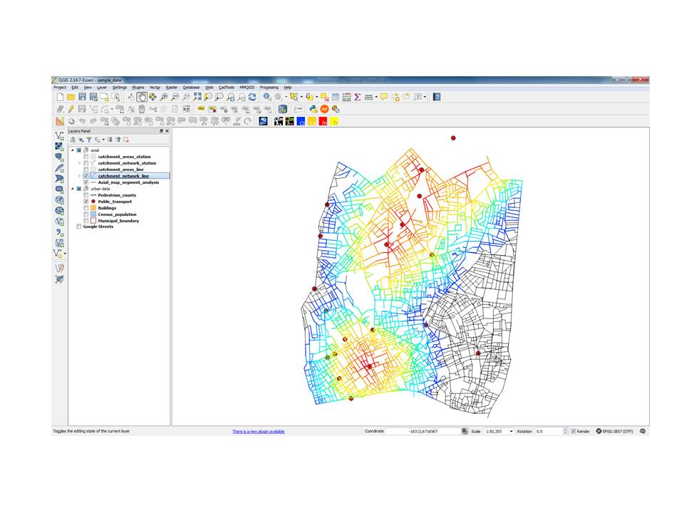

1. **Visualise the catchment polygons**
   1. Right-click the layer "**catchment_polygon_station**" and select the Joins tab. You are going to join the "**catchment_polygon_station**" with the “**public_transport**” layer to get the name of the origin stations in the "**catchment_polygon_station**". This is an attribute join.
   2. Click on the ‘+’ button to add a new vector join.
   3. Select Join Layer as “**public_transport**”, Join field as “**gid**” and target field as “**origin**”.
   4. Choose which fields to join and select “**name_of_st**”.
   5. Press OK. Right-click on the layer to open attribute table.
   6. Right-click the layer "**catchment_polygon_station**". Select the properties and select the Fields tab. See how the joined foiled distinguishes from other fields of the layer. The joined filed is not saved with the layer; the link is saved only in the workspace. To save the linked attribute save the layer as a new layer "**catchment_polygon_station_joined**".
   7. Right-click on the "**catchment_polygon_station**"
   8. Select the **‘Filter…’** tool
   9. Select the “**origin**” field under the “**Fields**” box
   10. To see available **Values**, click the **Sample** or the **All** button
   11. Add the ‘origin’ Field to the **filter expression box** at the bottom, by double-clicking or simply typing in **“origin”**
   12. Type “**=**” or use the operator button
   13. Type the station name or double-click the name in the Values box
   14. Click OK
   15. **The map now shows the polygons from the selected station.**

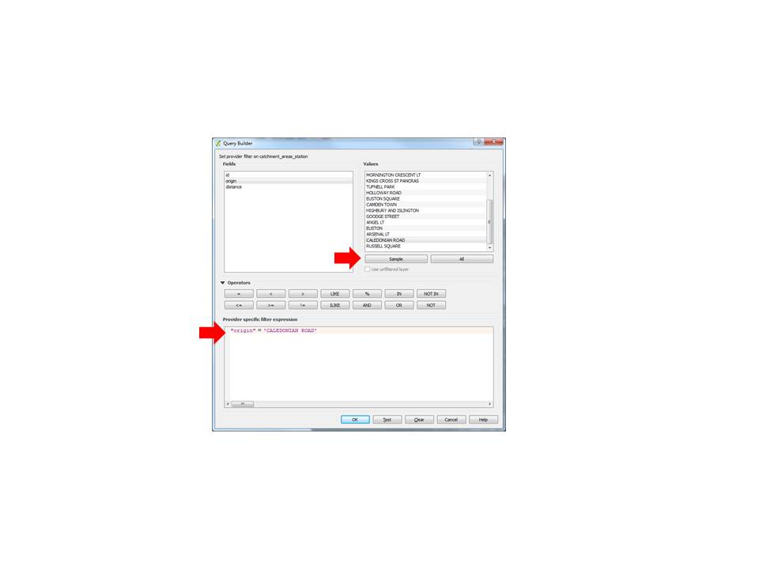

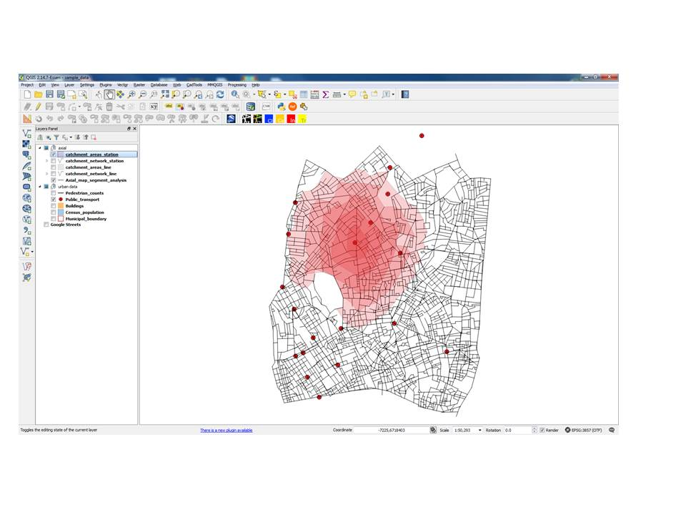

* 1. Filter for more than one station using the expression: **“origin” IN (‘station1’,’station2’)**
  2. Pay attention to the *commas* between the values and the *brackets* ()
  3. Toggle **‘Use Unfiltered Layer’** to get a list of all the values again.
  4. Filter for specific distances by adding the distance condition: **AND “distance” < 1200**
  5. Customise the colour and transparency you want under **Layer Properties > Style**

